Glamorous Invitation Cards: Sparkle and Shine with Style

In the realm of event planning, the Invite card design is the harbinger of anticipation and excitement. It's the first glimpse guests get into the tone and theme of the occasion, setting the stage for what's to come. When it comes to making a statement, nothing quite captures attention like glamorous invitation cards that sparkle and shine with style.

The Power of Glamour
Glamour is more than just a word; it's a feeling, an experience that elevates the ordinary into the extraordinary. When applied to invitation cards, glamour adds a touch of sophistication, allure, and allure that captivates recipients from the moment they lay eyes on it.
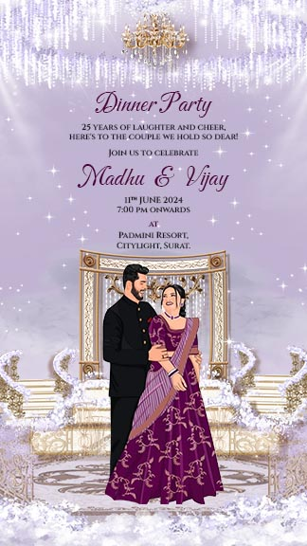

1. Embracing Elegance
Glamorous invitation cards exude elegance in every detail. From luxurious paper stock to intricate embellishments, every element is meticulously chosen to create a sense of opulence and refinement.

2. Captivating Creativity
Creativity knows no bounds when it comes to glamorous invitation cards. Whether it's a shimmering foil stamp, a delicate lace overlay, or a bold metallic accent, there are endless ways to infuse your invitations with style and flair.

3. Making a Memorable Impression
A glamorous invitation card is more than just a piece of paper; it's a work of art that leaves a lasting impression. It's a reflection of your personality, your taste, and your attention to detail, making it an integral part of the event experience.


Designing Your Dream Invitation
Creating glamorous invitation cards is an art form unto itself, requiring a delicate balance of creativity, craftsmanship, and attention to detail. Here are some tips for designing your dream invitation:

1. Choose the Right Materials
Start by selecting high-quality materials that exude luxury and sophistication. Opt for premium paper stock, shimmering cardstock, or textured finishes to add depth and dimension to your invitations.

2. Add a Touch of Sparkle
Incorporate elements that add sparkle and shine to your invitation, such as metallic foils, glitter accents, or crystal embellishments. These subtle touches catch the light and create a sense of glamour that's sure to impress your guests.


3. Focus on Typography
Typography plays a crucial role in setting the tone for your invitation. Choose fonts that are elegant, legible, and reflective of the overall theme of your event. Experiment with different styles, sizes, and colors to find the perfect combination that speaks to your style.

Setting the Stage for Success
Once you've designed your glamorous Card design for invitation, it's time to set the stage for a memorable event. Here are some tips for ensuring that your invitations make a splash:

1. Send Them in Style
Make a statement from the moment your invitations arrive by packaging them in style. Consider using decorative envelopes, custom wax seals, or silk ribbons to add an extra layer of sophistication to your presentation.

2. Create a Cohesive Experience
Extend the glamour of your invitation cards to every aspect of your event, from the décor to the entertainment. Incorporate elements that tie back to your invitation design, such as metallic accents, sequin tablecloths, or crystal centerpieces, to create a cohesive and memorable experience for your guests.

3. Capture the Moment
Don't forget to document the glamour of your event with stunning photographs that capture the essence of the occasion. Hire a professional photographer or set up a DIY photo booth with glamorous backdrops and props to ensure that every moment is captured in style.

Conclusion: Sparkle and Shine
Glamorous invitation cards are more than just pieces of paper; they're works of art that set the stage for unforgettable events. By infusing your invitations with style, sophistication, and a touch of sparkle, you create an experience that dazzles and delights from start to finish. So go ahead, unleash your creativity, and let your invitations sparkle and shine with style.

